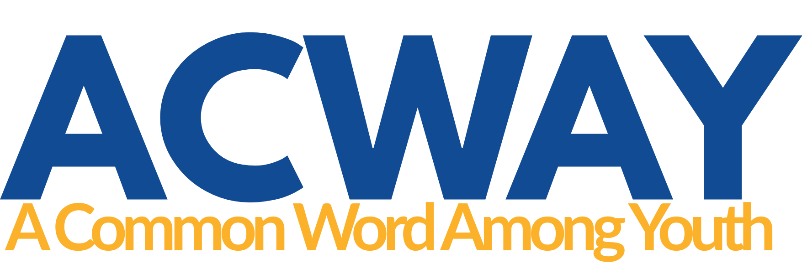

ACWAY Fellows Seed Funding:
Project Proposal

Before You Begin
This template is designed to help ACWAY Fellows present a clear, practical project idea. You do not need to use technical project-management language. We want to understand what you plan to do, why it matters to your community, and how you will make it happen.
- Complete all sections of this template and submit it with your application.
- Keep responses concise and within the suggested word limits.
- Complete the separate ACWAY Project Budget Template.
- Applications will be assessed for IDG alignment, impact, feasibility, community engagement, sustainability, and value for money.

Project Information
Applicant(s) | First name, Last name
Project title | Click or tap here to enter text.
Implementation country/location | List all locations in [city, country] order
Project start date | DD/MM/YYYY
Project end date | DD/MM/YYYY
Funding tier | Micro grant – Up to USD 500  Seed grant – USD 500-1,000  Impact grant – USD 1,000-2,000
Amount requested from ACWAY | Enter amount in USD
Total project cost | Enter amount in USD

Project Summary
Type here
Briefly explain what you want to do, who the project is for, where it will take place, and what you hope it will achieve. Maximum 200 words.

Background and Rationale
What issue, challenge or opportunity are you addressing? Why does it matter in your community, and why is this project needed? Maximum 300 words.
Type here

ACWAY Interfaith Development Goal Alignment
Primary ACWAY IDG
Additional IDG(s), if applicable | List any additional IDGs or write N/A
Explain how the proposed activities will contribute to the primary IDG and, where relevant, any additional IDGs. Maximum 100 words.
Type here

Project Objectives
List up to three specific objectives. Objectives should describe what the project intends to achieve.
Objective | What the project intends to achieve
1 | Type objective 1
2 | Type objective 2
3 | Type objective 3

Project Activities and Timeline
Set out the main activities in the order they will take place. Add rows if needed.
Activity | Description | Timing | Who will be involved
1 | Activity and key steps | DD/MM/YYYY | People/partners
2 | Activity and key steps | DD/MM/YYYY | People/partners
3 | Activity and key steps | DD/MM/YYYY | People/partners
4 | Activity and key steps | DD/MM/YYYY | People/partners
5 | Activity and key steps | DD/MM/YYYY | People/partners

Participants and Community Engagement
Who will participate in or benefit from the project? Approximately how many people do you expect to engage? How will the relevant community be involved in planning, delivery, participation or follow-up? Maximum 100 words.
Type here

Expected Results and Evidence
Identify the main results you expect and how you will know whether they happened. Keep the measures simple and realistic for the size of your project.
Expected result | How will you know it happened | Evidence you will collect
Result 1 | Indicator/measure | e.g. attendance, survey, feedback, output
Result 2 | Indicator/measure | Evidence
Result 3 | Indicator/measure | Evidence

Sustainability
What, if anything, do you hope will continue after the ACWAY-funded project ends? This might include continued activities, relationships, resources, partnerships, community ownership, or follow-up actions. Maximum 100 words.
Type here

Risks and Mitigation
Identify the main risks that could affect delivery and explain how you would manage them. Focus on practical risks that are genuinely relevant to your project.
Main risk | How will you manage?
Risk 1 | Mitigation
Risk 2 | Mitigation
Risk 3 | Mitigation

Project Team and Partners
Who will be responsible for implementing the project? Briefly describe your role and if any, the role of any partners, volunteers, facilitators or community organizations involved. Maximum 200 words.
Type here

Budget Summary
Provide a high-level summary here and submit detailed costs in the separate ACWAY Project Budget Template. Co-funding or in-kind contributions are welcome but are not required. The amount requested should reflect the actual needs of the project and should be justified in the separate budget.
Total project cost | USD Enter amount
Amount requested from ACWAY | USD Enter amount
Other cash contributions | USD Enter amount
In-kind contributions | Brief description or N/A

